 | Data Analytics

5G Mobile Network Performance in France

Zidene Aourdache
Sept. 2026

Sept.,2026t
Table of content

Contents
1. Introduction 5
1.1 Context 5
1.2. Business Question 5
1.3. Objectives 5
2. Data and Data Sources 6
2.1. ARCEP Mobile Quality of Service Data 6
2.2. ARCEP Mobile Sites Data 7
2.3. INSEE Demographic and Geographical Data 8
2.4. Data Sources Overview 8
3. Data Collection Methods 9
3.1. Web Scraping – ARCEP Data 9
3.2. API – INSEE Population Data 10
3.3. Flat File Reading – INSEE Geographical Data 11
3.4. Summary of Data Collection Methods 11
4. Data Cleaning and Exploratory Data Analysis 12
4.1. Data Cleaning 12
4.1.1. Removal of Empty Columns 12
4.1.2. Date Parsing and Standardisation 12
4.1.3. Data Type Conversion 12
4.1.4. Normalisation of the situation Column 12
4.1.5. Geographical Consistency 12
4.1.6. Duplicate Removal 13
4.1.7. Final Validation 13
4.2. Exploratory Data Analysis 13
5. Database Type Selection and SQL Database Creation 15
5.1. Database Type Selection 15
5.2. Database Structure 15
5.3. Database Creation 15
5.4. SQL Queries for Data Analysis 16
6. Entities and Entity-Relationship Diagram 19
6.1. Database Entities 19
6.2. Entity Relationships 19
7. API Development & Exposing Data via API 21
7.1 API Development with Flask API 21
9. ML Process: 22
9. EU GDPR 23

Introduction

1.1 Context
Mobile connectivity has become an essential part of everyday digital activity. Users increasingly rely on mobile networks for web browsing, video streaming, file transfers and professional applications. However, network quality is not uniform across territories. Differences in infrastructure deployment, radio conditions, population distribution and operator strategies may contribute to variations in measured performance.

The French telecommunications regulator, ARCEP (Autorité de régulation des communications électroniques, des postes et de la distribution de la presse), publishes mobile Quality of Service (QoS) measurements covering Metropolitan France. These measurements provide a valuable source for analysing mobile network performance using real-world measurement data.

This project focuses specifically on 5G performance and combines ARCEP QoS measurements with mobile-site infrastructure data and demographic information from INSEE (Institut national de la statistique et des études économiques).

1.2. Business Question
The central question of the project is:

“Are there significant territorial inequalities in mobile network performance in France, and what can explain these disparities?”

The analysis has two complementary objectives. First, it measures and compares 5G performance between the four mobile operators, across French regions and across different territorial contexts. Second, it investigates potential factors associated with these differences, focusing on network infrastructure, population and radio conditions.

1.3. Objectives
The project objectives are to:
- Collect and prepare 5G QoS data.
- Collect mobile infrastructure information.
- Extract commune-level population data from INSEE.
- Integrate the datasets using the commune INSEE code.
- Build a relational database in MySQL.
- Create a denormalized analytical layer in BigQuery.
- Analyse network performance using Python and SQL.
- Test whether observed operator differences are statistically significant.
- Investigate relationships between performance and potential explanatory variables.
- Develop a Power BI dashboard to communicate the findings.

Data and Data Sources
The analysis is based on three complementary data sources: ARCEP mobile Quality of Service (QoS) measurements, ARCEP mobile-site infrastructure data, and INSEE demographic and geographical data. These sources were selected because they provide complementary information on network performance, infrastructure deployment and territorial context.

2.1. ARCEP Mobile Quality of Service Data
The main performance dataset comes from the French telecommunications regulator ARCEP. It contains measurements from the 2025 mobile Quality of Service campaign for Metropolitan France.
Source:
https://data.arcep.fr/mobile/mesures_qualite_arcep/2025/Metropole/
The dataset contains measurements for different mobile usage scenarios, including:
- WEB – web page loading performance;
- STREAM – video streaming quality;
- DOWNLOAD – download speed;
- UPLOAD – upload speed.
It also contains information about the operator, measurement date and time, geographical location and radio conditions. In particular, RSRP and RSRQ indicators were used to characterize the radio environment.
The raw QoS dataset contains approximately 354,000 measurement records and 103 variables before cleaning and transformation.
Below a snapshot of the initial raw QoS file:
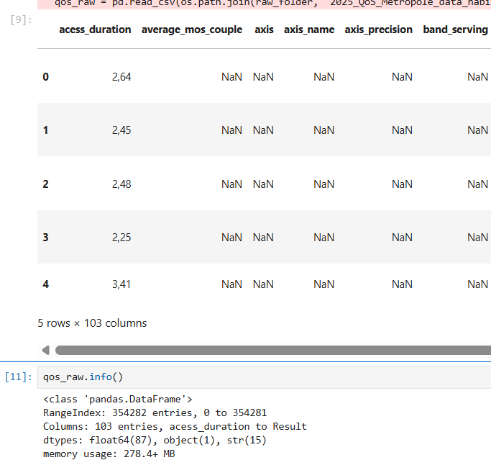
Figure 1 – Raw QoS Data

2.2. ARCEP Mobile Sites Data
A second ARCEP dataset describes mobile network infrastructure in Metropolitan France. It provides information about mobile sites, their geographical location, operators and deployed network technologies.
Source:
https://data.arcep.fr/mobile/sites/
The dataset includes information such as:
- mobile-site identification;
- operator;
- commune and administrative area;
- geographical coordinates;
- network technologies;
- frequency bands and deployment indicators.
This dataset is used to characterize network infrastructure and 5G deployment at territorial level. In the analysis, physical sites and real 5G deployment indicators are used to investigate whether differences in infrastructure are associated with differences in measured network performance.

2.3. INSEE Demographic and Geographical Data
The third source is the French National Institute of Statistics and Economic Studies (INSEE). Population and geographical information is used to provide demographic and territorial context to the network measurements.
Source:
https://www.insee.fr/fr/statistiques/8581810
The data provides information at commune level, including:
- commune identification;
- department and region;
- population;
- geographical and administrative identifiers.
The commune INSEE code (insee_com) is used as the main geographical key to connect the ARCEP QoS measurements, ARCEP infrastructure data and INSEE demographic information.

2.4. Data Sources Overview
Source | Data | Main analytical purpose
ARCEP | Mobile QoS measurements | Measure network performance
ARCEP | Mobile sites | Analyse infrastructure and 5G deployment
INSEE | Population and geography | Analyse demographic and territorial context

Together, these sources provide three complementary dimensions of the analysis: measured network performance, network infrastructure and territorial characteristics. Their integration makes it possible to investigate not only whether performance differences exist, but also which territorial factors are associated with these differences.

3. Data Collection Methods
The three main data sources were collected using different Python-based methods, depending on the format and accessibility of each source. The project used web scraping for ARCEP data, an API for INSEE population data, and flat-file reading for INSEE geographical data.

3.1. Web Scraping – ARCEP Data
The ARCEP datasets were published through the ARCEP open-data website. Python was used to automate the retrieval of the required files rather than downloading and processing each file manually.
The script:
- accesses the ARCEP data source;
- identifies the relevant 2025 Metropolitan France dataset;
- retrieves the data file;
- stores the raw data locally for subsequent processing.
The same approach was applied to both the ARCEP Mobile QoS and ARCEP Mobile Sites datasets.

Python implementation – ARCEP web scraping
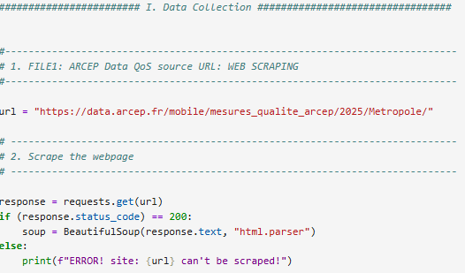
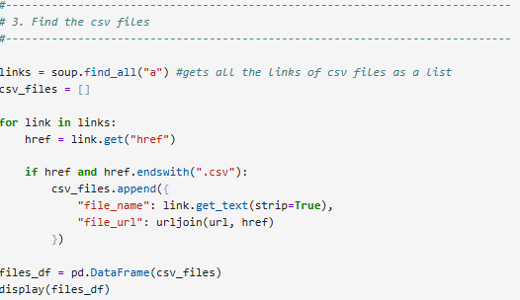
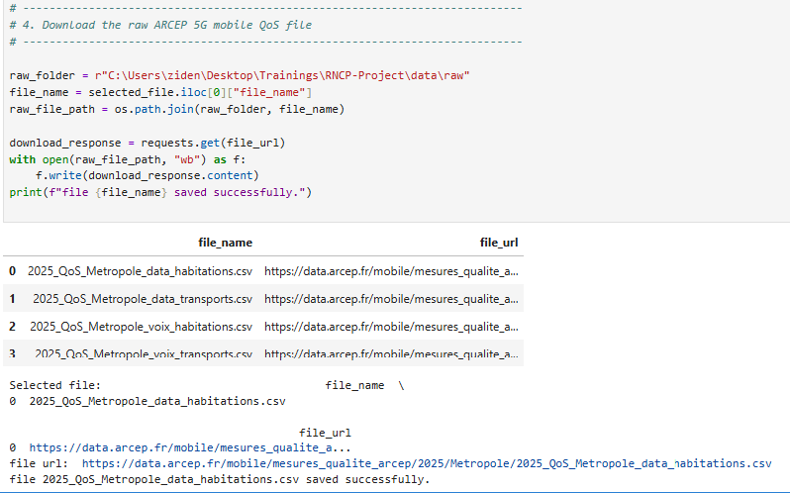
Figure 2 – Python code used to retrieve ARCEP data

The raw files were preserved separately from the processed datasets so that the original source data remained available throughout the project.

3.2. API – INSEE Population Data
Population data was retrieved from INSEE using an API-based approach. This method allowed the required demographic information to be requested programmatically rather than manually downloading individual datasets.
The Python code:
- constructs the API request;
- sends the request to the INSEE service;
- retrieves the returned data;
- converts the response into a structured Python/Pandas dataset;
- prepares the population data for subsequent integration with the ARCEP datasets.
The commune INSEE code was retained as the geographical identifier to allow the population data to be linked with network measurements.

Python implementation – INSEE API
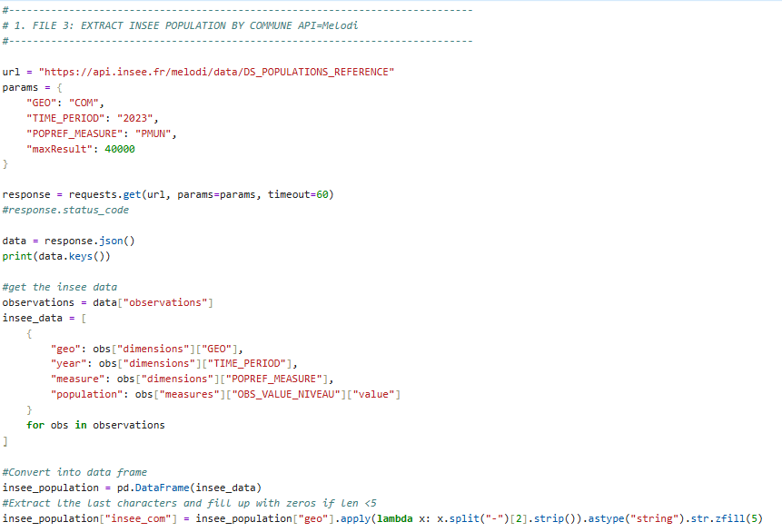
Figure 3 – Python code used to retrieve INSEE population data through the API

3.3. Flat File Reading – INSEE Geographical Data
Additional geographical information was provided as a local flat file. The file was read directly into Python using Pandas.
The Python code:
- identifies the location of the file url;
- reads the file into a Pandas DataFrame using: pd.read_csv(url)
- interprets the required columns and data types;
- prepares the geographical information for integration with the other datasets.

This dataset provides the commune, department and region information required for the territorial analysis.

3.4. Summary of Data Collection Methods
Method | Source | Python approach | Purpose
Web scraping | ARCEP QoS and Mobile Sites | Automated retrieval of ARCEP files | Collect network performance and infrastructure data
API | INSEE population | API request and response processing | Retrieve population data programmatically
Flat file reading | INSEE geographical data | Pandas file import | Load commune and administrative geography
Using these three methods allowed the project to combine data from different technical sources while keeping the acquisition process reproducible and programmatic.

4. Data Cleaning and Exploratory Data Analysis
After data acquisition, the datasets were cleaned and validated before being integrated. The cleaning process was performed mainly with Python and focused on data quality, consistency and geographical compatibility.

4.1. Data Cleaning

4.1.1. Removal of Empty Columns
The raw ARCEP QoS file contained several columns with no useful information for the analysis. These empty columns were identified and removed to simplify the dataset and avoid unnecessary variables during the subsequent processing.

4.1.2. Date Parsing and Standardisation
Date and time variables were converted into appropriate Python date/time formats. This ensured that measurements could be correctly ordered and analysed chronologically if needed.
The measurement date was also standardised to provide a consistent format across the dataset.

4.1.3. Data Type Conversion
The columns were examined and converted to appropriate data types.
Numerical measurements, identifiers and categorical variables were separated according to their analytical purpose. This was particularly important for performance indicators such as download and upload speeds and for geographical identifiers used during data integration (insee_com as string).

4.1.4. Normalisation of the situation Column
The situation variable in the QoS dataset contained categorical information describing the measurement context.
Its values were standardised to ensure that equivalent situations were represented consistently. This prevented differences in spelling, formatting or categorical representation from creating artificial categories during the analysis.

4.1.5. Geographical Consistency
The three datasets — QoS, Mobile Sites and Population — were linked using the commune INSEE code (insee_com).
Before integration, the commune identifiers were compared between the datasets. Communes that were not common to the three datasets were removed from the integrated analysis dataset.
This ensured that each geographical observation used in the analysis had the required network performance, infrastructure and demographic information.

4.1.6. Duplicate Removal
Duplicate records were identified and removed where necessary.
This step was particularly important for ensuring that individual measurements or geographical records were not counted more than once and that aggregated indicators were not biased by duplicated observations.

4.1.7. Final Validation
After the cleaning operations, the datasets were checked again for:
- missing or invalid values;
- duplicate records;
- consistent data types;
- valid commune identifiers;
- consistency between operators and protocols;
- successful geographical integration.
The resulting datasets were then used for exploratory analysis.

4.2. Exploratory Data Analysis
The Exploratory Data Analysis (EDA) was performed using Python, SQL and Power BI.
The objective was to understand the distribution of network performance and identify potential relationships between download performance and the main explanatory factors.
The analysis focused primarily on download speed (bitrate_dl), while the other QoS indicators were used to provide additional context.
Three main dimensions were investigated:
- Infrastructure: physical sites and 5G deployment;
- Population: regional population and territorial concentration;
- Radio environment: RSRP and RSRQ indicators.
Operator-level comparisons were also performed to identify differences in average download performance.
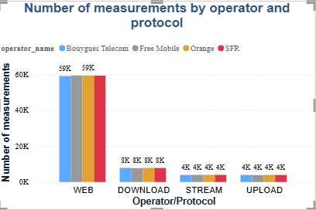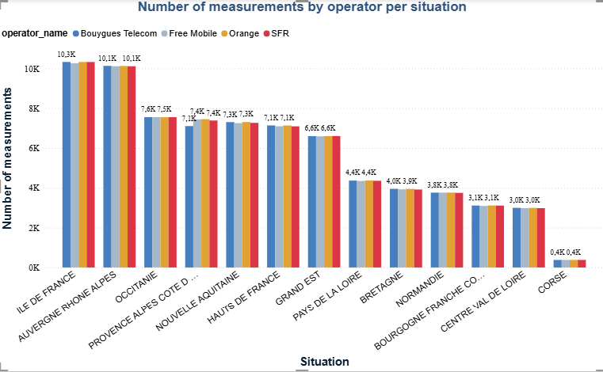
Figure 4 – measurements distribution

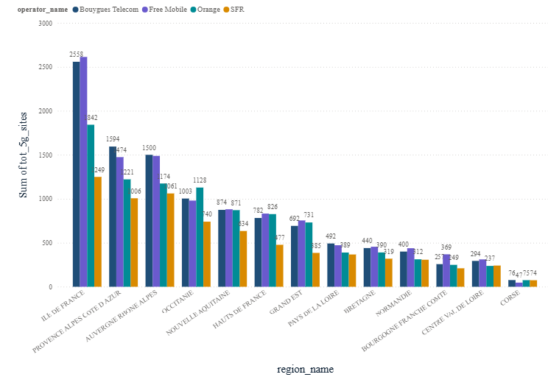
Figure 5 – Infrastructure distribution

5. Database Type Selection and SQL Database Creation

5.1. Database Type Selection
After cleaning and integrating the datasets, a database was required to store the structured data and facilitate querying and analysis.
A relational SQL database was selected because the project contains structured data with clearly defined relationships between measurements, geographical areas, operators, infrastructure and population.
The main reasons for choosing a relational database were:
- the data is highly structured and tabular;
- datasets can be connected using common identifiers;
- relationships between entities can be explicitly defined;
- SQL provides efficient filtering, aggregation and joining capabilities;
- data integrity can be controlled through keys and constraints;
- the database provides a reusable data layer for subsequent analysis.
MySQL was selected as the relational database management system.
The resulting database was named:
mobile_5g_network_fr

5.2. Database Structure
The database was designed around the main entities of the project.
The principal components were:
- QoS measurements – network performance measurements;
- Mobile sites – infrastructure and deployment information;
- Geography – communes, departments and regions;
- Operators – mobile network operators;
- Population – demographic information.
The geographical dimension plays a central role because the commune INSEE code (insee_com) provides the common identifier used to connect the different datasets.
This relational structure avoids unnecessarily duplicating geographical and demographic information and makes it possible to query the data from different analytical perspectives.

5.3. Database Creation
The MySQL database was created using MySQL Workbench.
The cleaned datasets were loaded into the corresponding tables after the database structure had been defined. Primary keys and relationships were used where appropriate to maintain data consistency.
The implementation process consisted of:
- creating the mobile_5g_network_fr database;
- creating the required tables;
- defining columns and data types;
- defining primary and foreign keys;
- loading the cleaned datasets;
- checking record counts and relationships;
- executing SQL queries to validate the database.

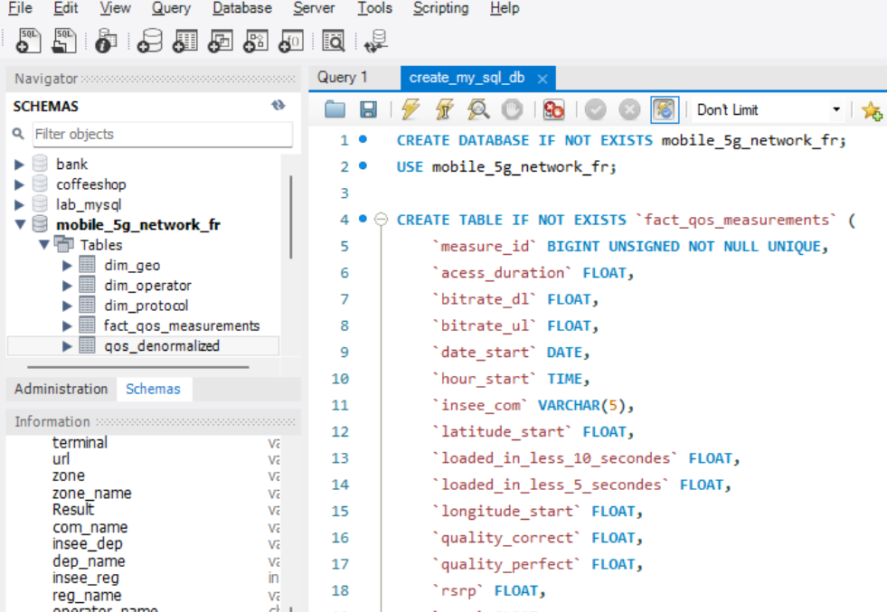
Figure 6 – MySQL database creation

5.4. SQL Queries for Data Analysis
Once the database was populated, SQL queries were used to verify the data and perform initial analytical operations.
Queries were used to:
- filter measurements by operator, protocol or geographical area;
- calculate aggregated performance indicators;
- compare operators;
- join QoS measurements with infrastructure and population data;
- verify the consistency of the integrated data.
The SQL layer therefore provided both a structured storage solution and an additional analytical tool before the data was used for statistical analysis and visualization.

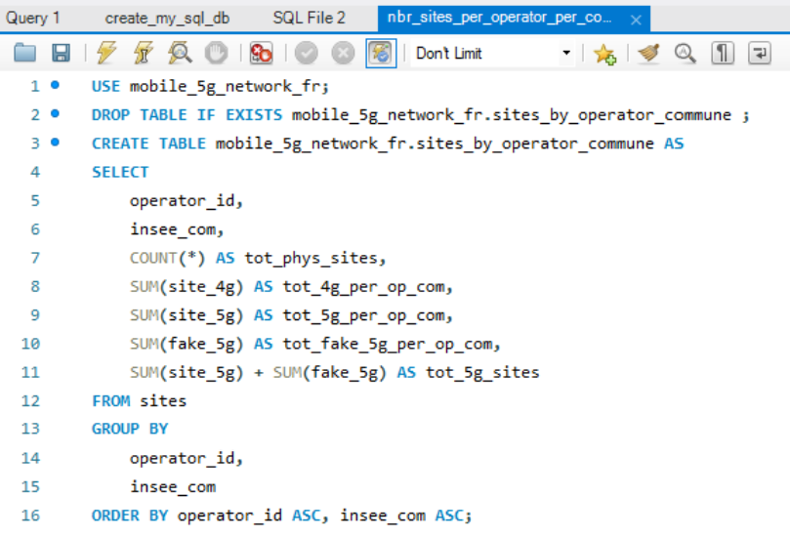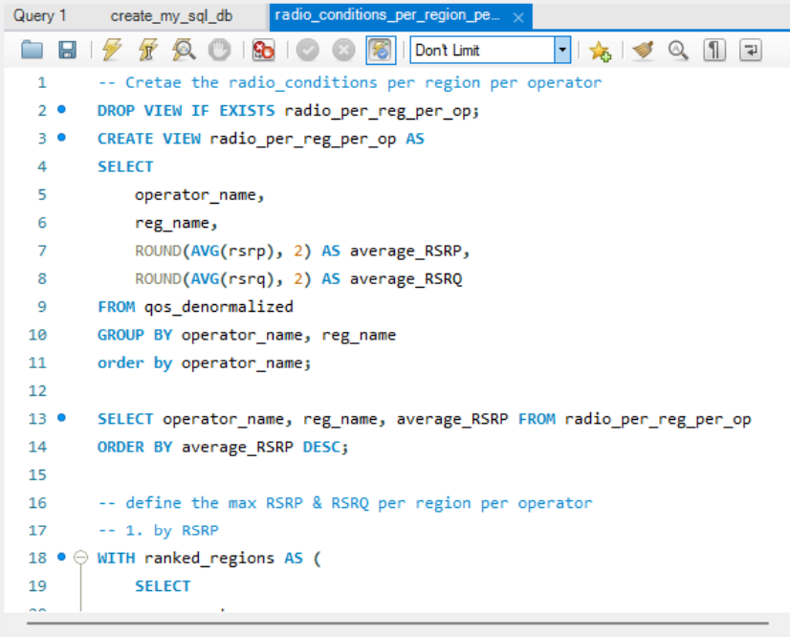

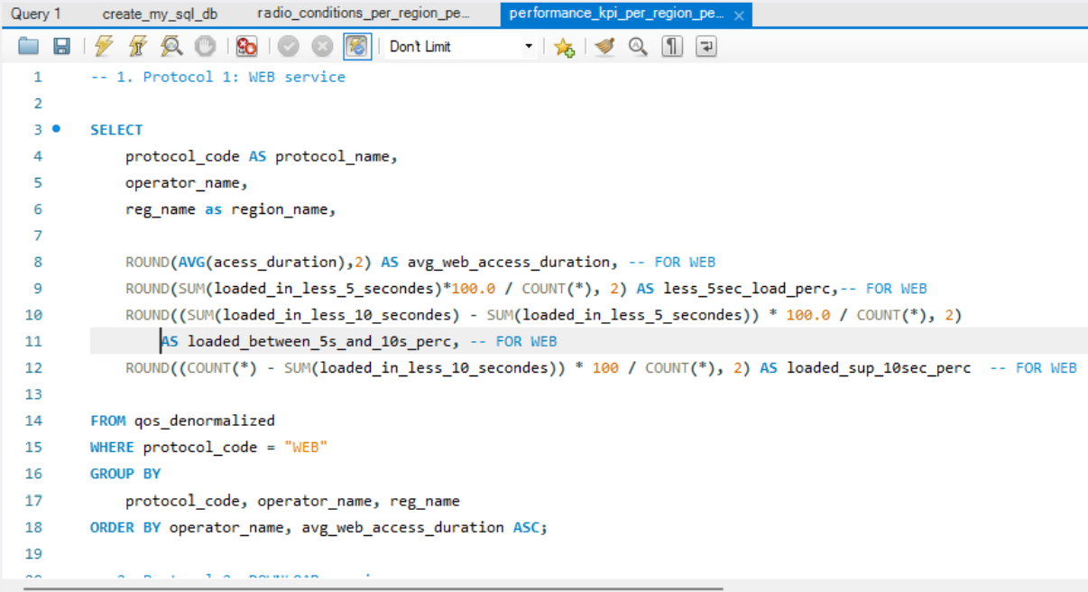
Figure 7 – Example SQL query used for analysis

6. Entities and Entity-Relationship Diagram

6.1. Database Entities
The relational database was organised around the main entities required to represent the mobile network analysis.
The principal entities are: (check ERD)
- FACT_QOS – contains the mobile network performance measurements;
- DIM_GEO – contains commune, department and region information;
- DIM_OPERATOR – contains mobile operator information;
- FACT_SITES – contains mobile-site and network deployment information;
- DIM_POPULATION – contains population information associated with geographical areas.
The database follows a fact/dimension structure, where the QoS and site tables contain measurements or infrastructure records, while the dimension tables provide descriptive information.
Main identifiers
The principal relationships are based on:
- insee_com – commune INSEE code, used to connect network data with geographical and population information;
- operator_id – operator identifier, used to associate QoS measurements with the corresponding operator;
- site identifiers – used to uniquely identify infrastructure records.

6.2. Entity Relationships
The DIM_GEO entity is central to the model because geographical information is shared by the different datasets.
The main relationships are:
DIM_GEO
↕ insee_com
FACT_QOS
DIM_GEO
↕ insee_com
FACT_SITES
DIM_GEO
↕ insee_com
DIM_POPULATION
The QoS measurements are also associated with the operator dimension through operator_id.
This structure allows network performance to be analysed together with infrastructure, operator and demographic information while reducing unnecessary duplication of descriptive data.

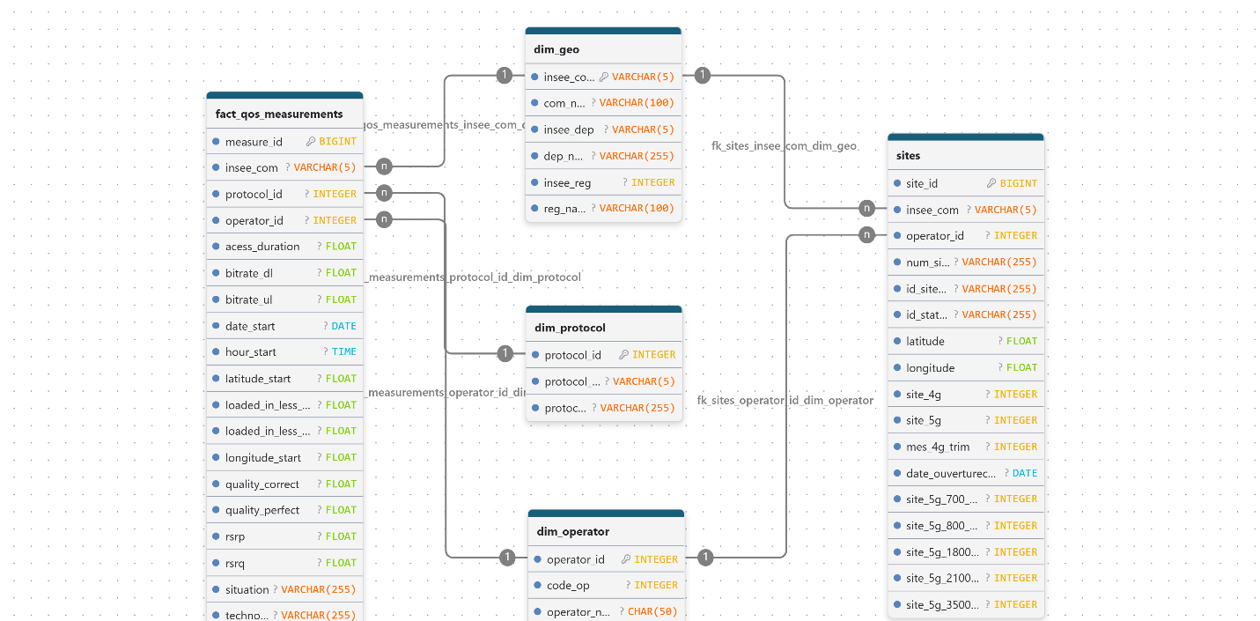
Figure 8 – Relational database structure

7. API Development & Exposing Data via API

7.1 API Development with Flask API
To facilitate access to a dataset stored in a MySQL database, an API was developed using Flask, a popular micro web framework written in Python. This API is designed to serve as a bridge between the database and users wishing to retrieve data, enhancing data accessibility and interaction for various applications and research purposes. Flask's lightweight and extensible nature makes it an excellent choice for creating RESTful APIs, which follow a stateless, client-server architecture where each request from any client contains all the information needed to service the request.
The API provides access to the stored data through three distinct endpoints, each designed to serve a specific segment of the dataset. These endpoints are as follows:

Type | Description | Endpoints
Commune/operator Qos | This endpoint allows users to retrieve information  related to commune QoS by Telecom Operator. It's useful for applications and analyses that focus on QoS analysis. Thi gives alle the measurements of the specified operator in the specified commune | "/api/qos"
Commune/operator infrastructure | This endpoint gives deployment information about 5G sites. It allows users get the number of available 5G infrastructure, per commune, together with the average of download speed and upload speed specific to that location | "/api/communal_stats"
Regional aggregated QoS | This gives aggregated QoS per region. | /api/regional_qos

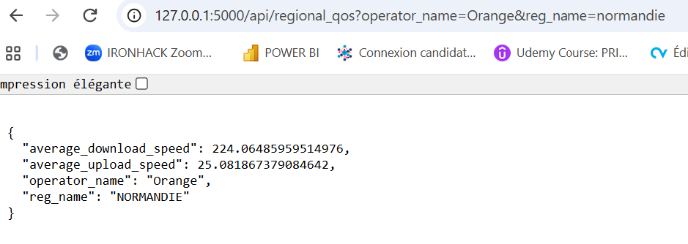
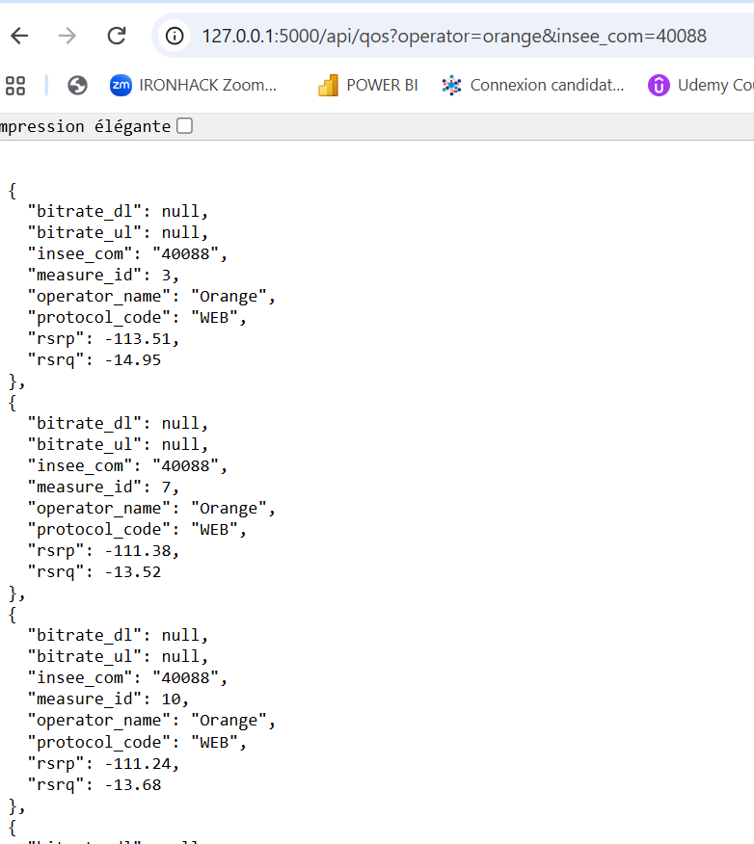
Figure 8 – Snapshots of API endpoints

9. ML Process:
2 ML Models were trained on the dataset, leading to the following result and conclusion:

Model | R² | MAE (Mbps) | RMSE (Mbps)
Decision Tree | 0.478 | 81 | 113
Linear Regression | 0.385 | 99 | 123

• The Decision Tree achieved R² = 0.478, meaning that the selected variables explain approximately 48% of the variation in download speed on the test communes.
• Linear Regression achieved R² = 0.385.
• The Decision Tree also produced lower MAE (81.11 Mbps) and RMSE (113.32 Mbps) than Linear Regression.
• This suggests that the relationship between download performance and the selected variables is not purely linear and may involve interactions or threshold effects.
• The models also show that the available explanatory variables capture part, but not all, of the territorial variation in 5G performance.

10. EU GDPR

General Data Protection Regulation (EU GDPR) was considered for this project. None of the data sets used contain any personal data of any kind. https://eur-lex.europa.eu/legal-content/EN/TXT/?uri=CELEX%3A02016R0679-20160504

